**semiAutomatic shotguns**

**MODEL 11**

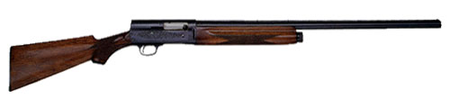

**Overview:**

|  |  |
| --- | --- |
| **Manufacturer:** | **Remington** |
| **Description:** | First autoloading shotgun produced in the U.S.A. |
|  |  |
| **Introduction Year:** | 1905 |
|  |  |
| **Year Discontinued:** | 1947 |
|  |  |
| **Total Production:** | Approximately 850,000 (including 65,000 made for Browning during World War II) |
|  |  |
| **Designer/Inventor:** | John F. Browning with subsequent improvements by C.C. Loomis and other Remington designers |
|  |  |
| **Action Type:** | Recoil operated – Hammerless – Side ejection – Take Down |
|  |  |
| **Caliber/Gauge:** | 12, 16, 20 gauges |
|  |  |
| **Serial Number Blocks:**  **Grades Offered:**  **Variations:** | 12 gauge – approximately 10,000 – 794,990 16 gauge – approximately 1,500,000 – 1,557,000 20 gauge – approximately 1,000,000 – 1,075,000  11 A – Standard Grade 11 R – Riot Special 11 P – Police Special 11 B – Special Grade 11 C – Trap Grade 11 D – Tournament Grade 11 E – Expert Grade 11 F – Premier Grade  Sportsman |
|  |  |

**Sportsman**



**Overview:**

|  |  |
| --- | --- |
| **Manufacturer:** | **Remington** |
| **Description:** | Improved 3-shot version of the Model 11 with a re-styled beavertail fore-end and decorations on the breech |
|  |  |
| **Introduction Year:** | 1931 |
|  |  |
| **Year Discontinued:** | 1947 |
|  |  |
| **Total Production:** | Approximately 140,000 |
|  |  |
| **Designer/Inventor:** | John F. Browning with subsequent improvements by C.C. Loomis and other Remington designers |
|  |  |
| **Action Type:** | Autoloading |
|  |  |
| **Caliber/Gauge:** | 12, 16, 20 gauge |
|  |  |
| **Serial Number Blocks:**  **Grades Offered:**  **Variations:** | 12 ga. – 500,000 – 1,132,000 16 ga. – 200,000 – 250,000 20 ga. – 1,036,000 – 1,081,000 *All serial numbers for this model used an "S" prefix.*  Field grade Riot grade Skeet grade  None |

**SPORTSMAN 48**

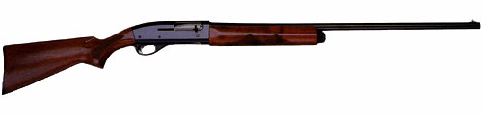

**Overview:**

|  |  |
| --- | --- |
| **Manufacturer:** | **Remington** |
| **Description:** | 3-shot version of the Model 11-48 autoloading shotgun |
|  |  |
| **Introduction Year:** | 1948 |
|  |  |
| **Year Discontinued:** | 1968 |
|  |  |
| **Total Production:** | Approximately 276,000 |
|  |  |
| **Designer/Inventor:** | L. Ray Crittendon, Ellis Hailston, and C.R. Johnson |
|  |  |
| **Action Type:** | Autoloading |
|  |  |
| **Caliber/Gauge:** | 12, 16, 20 gauges |
|  |  |
|  |  |
| **Serial Number Blocks:** | 12 ga. – 3,000,000 – 3,157,000 16 ga. – 3,500,000 – 3,568,000 20 ga. – 3,800,000 – 3, 854,000 |
| **Variations:** | Sportsman '48A Standard Grade Sportsman '48B Special Grade Sportsman '48D Tournament Grade Sportsman '48F Premier Grade Sportsman '48 Skeet Grade |

**Mohawk 48**



**Overview:**

|  |  |
| --- | --- |
| **Manufacturer:** | **Remington** |
| **Description:** | 3-shot version of the Model 11-48 autoloading shotgun |
|  |  |
| **Introduction Year:** | 1948 |
|  |  |
| **Year Discontinued:** | 1968 |
|  |  |
| **Total Production:** | Approximately 276,000 |
|  |  |
| **Designer/Inventor:** | L. Ray Crittendon, Ellis Hailston, and C.R. Johnson |
|  |  |
| **Action Type:** | Autoloading |
|  |  |
| **Caliber/Gauge:** | 12, 16, 20 gauges |
|  |  |
|  |  |

**SPORTSMAN 11-48**



**Overview:**

|  |  |
| --- | --- |
| **Manufacturer:** | **Remington** |
| **Description:** | A lighter, streamlined version, of the Model 11. The first new shotgun to be introduced by Remington after World War II. |
|  |  |
| **Introduction Year:** | 1949 |
|  |  |
| **Year Discontinued:** | 1968 |
|  |  |
| **Total Production:** | Approximately 455,535 |
|  |  |
| **Designer/Inventor:** | L. Ray Critendon, Ellis Hailston, and C.R. Johnson |
|  |  |
| **Action Type:** | Autoloading with a recoiling barrel action |
|  |  |
| **Caliber/Gauge:** | 12, 16, 20, 28, .410 gauges |
|  |  |
|  |  |
| **Serial Number Blocks:** | 12 ga. – Approximately 5,000,000 – 5,172,000* 16 ga. – Approximately 5,500,000 – 5,571,000 20 ga. – Approximately 5,800,000 – 5,848,000 28 ga. – Approximately 4,009,000 – 4,027,000 .410 – Approximately 4,100,000 – 4,125,000 *Some 12 ga. Models have serial numbers from approximately 20,000 – 213,000 |
| **Grades Offered:** | Model 11-48A – Standard Grade Model 11-48R – Riot Grade Model 11-48B – Special Grade Model 11-48D – Tournament Grade Model 11-48F – Premier Grade Model 11-48 RSS – Rifled Slug Special |
| **Variations:** | Model Sportsman ‘48 |

**Sportsman 58 magnum**



**Overview:**

|  |  |  |
| --- | --- | --- |
| **Manufacturer:** | **Remington** | |
| **Description:** | Remington's first gas operated, autoloading shotgun without the Browning-type recoiling action. | |
|  |  | |
| **Introduction Year:** | 1956 | |
|  |  | |
| **Year Discontinued:** | 1963 | |
|  |  | |
| **Total Production:** | 271,000 approx. | |
|  |  | |
| **Designer/Inventor:** | L.R. Crittendon, Phillip R. Haskell, Ellis W. Hailston | |
|  |  | |
| **Action Type:** | Gas operated, autoloading | |
|  |  | |
| **Caliber/Gauge:** | 12, 16 and 20 gauge | |
|  |  | |
|  |  | |
| **Serial Number Blocks:** | 1,000 – 275,000 | |
| **Grades Offered:** | ADL Deluxe BDL Deluxe Special D Tournament F Premier SA Skeet SC Skeet Target SD Skeet Tournament SF Skeet Premier TB Trap Special | |
| **Variations:** | Magnum 58 TX with Sun-grain maple stocks 58 SX with Sun-grain maple stocks 58RSS Rifled slug special | |
|  |  | |
|  | |  |

**SPORTSMAN 878 Automaster**



**Overview:**

|  |  |
| --- | --- |
| **Manufacturer:** | **Remington** |
| **Description:** | Lightweight, gas operated, autoloading shotgun "The Automaster". |
|  |  |
| **Introduction Year:** | 1959 |
|  |  |
| **Year Discontinued:** | 1963 |
|  |  |
| **Total Production:** | Approximately 65,000 |
|  |  |
| **Designer/Inventor:** | L. Ray Crittendon, Ellis Hailston, and C.R. Johnson |
|  |  |
| **Action Type:** | Autoloading |
|  |  |
| **Caliber/Gauge:** | 12, 16, 20 gauges |
|  |  |
|  |  |
| **Serial Number Blocks:** | 1001-65,000 approximate |
| **Grades Offered:** | A Grade – Field gun D Grade F Grade Skeet D & F grades |
| **Variations:** | ADL – roll engraved receiver & checkered wood ADX field gun BDL SA skeet – ventilated rib barrel, roll engraved receiver, checkered wood SX skeet – Sun grain stock and fore-end |

**Wards westernfield 600a eri**



**Overview:**

|  |  |
| --- | --- |
| **Manufacturer:** | **Remington** |
| **Description:** | Version of the Model 878 made for the Montgomery Ward Co. Highly decorated receiver and furniture. |
|  |  |
| **Introduction Year:** | 1959 |
|  |  |
| **Year Discontinued:** | 1963 |
|  |  |
| **Total Production:** | Approximately 10,000 |
|  |  |
| **Designer/Inventor:** | L. Ray Crittendon, Ellis Hailston, and C.R. Johnson |
|  |  |
| **Action Type:** | Autoloading |
|  |  |
| **Caliber/Gauge:** | 12gauge. |
|  |  |
|  |  |
| **Serial Number Blocks:** | N/A |
| **Grades Offered** | One |
| **Variations:** | None |

**MODEL 1100 magnum**

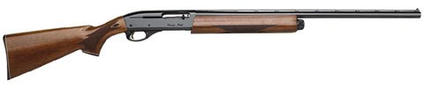

**Overview:**

|  |  |
| --- | --- |
| **Manufacturer:** | **Remington** |
| **Description:** | Gas operated 5-shot autoloading shotgun |
|  |  |
| **Introduction Year:** | 1963 |
|  |  |
| **Year Discontinued:** | Currently in production |
|  |  |
| **Total Production:** | N/A |
|  |  |
| **Designer/Inventor:** | Wayne Leek |
|  |  |
| **Action Type:** | Autoloading |
|  |  |
| **Caliber/Gauge:** | 12 gauge (1963) 16 gauge (1964) 20 gauge (1969) .410 bore (1969) |
|  |  |
|  |  |
| **Serial Number Blocks:** | Serial number blocks not available |
| **Grades Offered:** | Field SA Skeet SC Skeet TA Trap TB Trap TBMC Trap Tournament Grade Trap Tournament Grade Skeet D – Tournament Grade F – Premier Grade |
| **Variations:** | Magnum Duck Gun Lightweight 20 gauge in Field, Magnum, Skeet & Deer 150th Anniversary edition – 1966 Matched Pairs in .410 bore & 28 gauge skeet 1970 Left hand in 12 & 20 gauge Ducks Unlimited Commemorative versions Bicentennial model Limited Edition "One of Three Thousand" Special Field Special Purpose Synthetic Sporting Classic Field Youth |
|  |  |

**Sportsman 12 auto**



**Overview:**

**Manufacturer: Remington**

|  |  |
| --- | --- |
| **Description:** | Gas operated 5-shot autoloading shotgun |
|  |  |
| **Introduction Year:** |  |
|  |  |
| **Year Discontinued:** |  |
|  |  |
| **Total Production:** | N/A |
|  |  |
| **Designer/Inventor:** |  |
|  |  |
| **Action Type:** | Autoloading |
|  |  |
| **Caliber/Gauge:** | 12 gauge (1963) 16 gauge (1964) 20 gauge (1969) .410 bore (1969) |
|  |  |
|  |  |

**MODEL1100 g3**

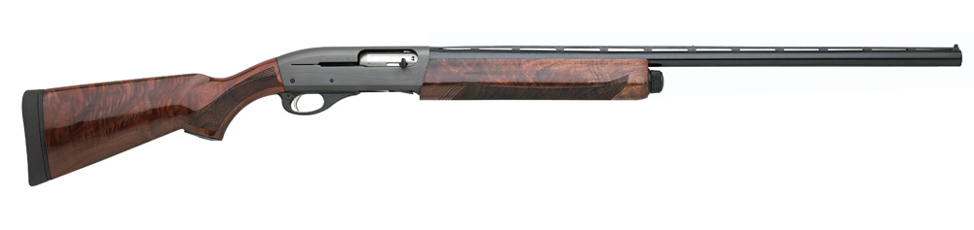

**Overview:**

|  |  |
| --- | --- |
| **Manufacturer:** | **Remington** |
| **Description:** | Gas operated 5-shot autoloading shotgun |
|  |  |
| **Introduction Year:** |  |
|  |  |
| **Year Discontinued:** | Currently in production |
|  |  |
| **Total Production:** | N/A |
|  |  |
| **Designer/Inventor:** | Wayne Leek |
|  |  |
| **Action Type:** | Autoloading |
|  |  |
| **Caliber/Gauge:** | 12, 20 gauge |
|  |  |
|  |  |
|  |  |
|  |  |

**11-96 Euro Lightweight**



**Overview:**

|  |  |
| --- | --- |
| **Manufacturer:** | **Remington** |
| **Description:** | 12-gauge autoloading lightweight, low-recoil shotgun. Voted 1997 Shotgun of the Year by Shooting Industry magazine. |
|  |  |
| **Introduction Year:** | 1996 |
|  |  |
| **Year Discontinued:** | 1999 |
|  |  |
| **Total Production:** | N/A |
|  |  |
| **Designer/Inventor:** | N/A |
|  |  |
| **Action Type:** | Autoloading |
|  |  |
| **Caliber/Gauge:** | 12 guage |
|  |  |
|  |  |
| **Serial Number Blocks:** | N/A |
| **Grades Offered:** | One |
| **Variations:** | None |
|  |  |

|  |  |
| --- | --- |
|  |  |

**SPR 453**

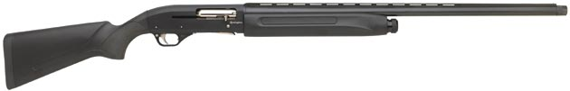

**Overview:**

|  |  |
| --- | --- |
| **Manufacturer:** | **Remington** |
| **Description:** | Gas operated 5-shot autoloading shotgun |
|  |  |
| **Introduction Year:** | 2006 |
|  |  |
| **Year Discontinued:** | 2008 |
|  |  |
| **Total Production:** | N/A |
|  |  |
| **Designer/Inventor:** | International Sporting Product manufactured in Baikal Russia. |
|  |  |
| **Action Type:** | Autoloading |
|  |  |
| **Caliber/Gauge:** | 12 gauge |
|  |  |
|  |  |
| **Serial Number Blocks:** | N/A |
| **Variations:** | SPR453 MO New Break Up SPR453 Synthetic |
|  |  |

**105cti**

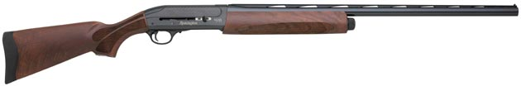

**Overview:**

|  |  |
| --- | --- |
| **Manufacturer:** | **Remington** |
| **Description:** | Gas Operated 5-shot Autoloading Shotgun; Bottom Load and Eject. |
|  |  |
| **Introduction Year:** | 2006 |
|  |  |
| **Year Discontinued:** | 2009 |
|  |  |
| **Total Production:** | N/A |
|  |  |
| **Designer/Inventor:** | Remington Arms Research & Development |
|  |  |
| **Action Type:** | Autoloading |
|  |  |
| **Caliber/Gauge:** | 12 gauge ProBore |
|  |  |
|  |  |
| **Serial Number Blocks:** | N/A $750.00 |
| **Variations:** | CTi (2006-2008)  CTi II (2008-2009) |
|  |  |

**SPORTSMAN 11-87**

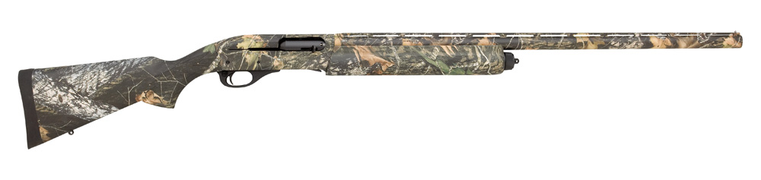

**Overview:**

|  |  |
| --- | --- |
| **Manufacturer:** | **Remington** |
| **Description:** | Pressure compensated autoloading shotgun. |
|  |  |
| **Introduction Year:** | 1987 |
|  |  |
| **Year Discontinued:** | Still in production |
|  |  |
| **Total Production:** | N/A |
|  |  |
| **Designer/Inventor:** | Research & Development |
|  |  |
| **Action Type:** | Autoloading shotgun |
|  |  |
| **Caliber/Gauge:** | 12-gauge (1987 - Present) 20-gauge (1999 - Present) |
|  |  |
|  |  |
| **Serial Number Blocks:** | N/A |
| **Variations:** | 175th Anniversary Premier (1991) CL Deer barrel w/ accessories (1991-1993) Fully rifled Deer Gun w/ accessories (1992-1993) Mag Deer Gun CL RC (1990-1993) NWTF Turkey Gun (1992) Premier (1987-1991) Premier LH (1987-1991) Premier 20-gauge (1999-2006) Premier Dale Earnhardt Tribute 12-gauge (2003) Premier Dale Earnhardt Tribute 20-gauge (2004) Premier Deer FR CL (1994-2006) Premier LC LH (1992-2006) Premier LC High Gloss (1992-2006) Premier LC Satin (1992-2002) Premier High Gloss 3” (1991) Premier Satin 3” (1991) Premier Skeet (1987-1998) Premier Skeet LH (1991-1994) Premier Trap (1987-1998) Premier Trap LH (1991-1994) Sporting Clays (1992-1999) Sporting Clays NP w/ ported barrel (1997-2000) Sportsman (2005 -Present) Sportsman Camo (2007 – Present) Sportsman Deer (Syn) (2007 -Present) Sportsman Field Walnut w/Fleur-De-Li Checkering (2010 – Present) Sportsman Synthetic (Authentic) (2005 – Present) Sportsman Synthetic Compact (2009 – Present) Sportsman Synthetic Compact Camo (2009 – Present) Sportsman Synthetic Shur Shot Stk (2008 – Present) Sportsman Youth 20-gauge (2005 -2008) Sportsman Super Mag (2008 – Present) Sportsman Super Mag Turkey (Shur Shot Stk) (2008 – Present) Sportsman Super Mag Waterfowl (2008 – Present) SP Mag (1987-2001) SP Mag Deer Gun RC RS (1989-2003) SP Super Mag Wood (2000-Present) Special Purpose Synthetic (SPS) (1991-2007) SPS Big Game Camo (1992-1996) SPS Deer (1993-2004) SPS FR CL Deer w/ sling & swivels (1994-2004) SPS RC CL Deer w/ sling & swivels (1994-1995) SPS Super Mag (2000-2007) SPS Super Mag Camo (2001-2007) SPS Super Mag Waterfowl (2007 - 2007) Special Purpose Synthetic Turkey (SPS-T) (1991-1999) SPS-T Camo (1993-2000) SPS-T Camo RS/TG (2000) SPS-T Camo w/ Leupold Red Dot Sights (2000) SPS-T Camo RealTree Extra Brown (1997) SPS-T Mag Camo Mossy Oak Greenleaf (1993-1996) SPS-T NWTF 25th Anniversary Special Edition (1998) SPS-T w/ cantilever & RC (2000-2003) SPS-T Super Mag Camo (2002-2007) SPS-T Super Mag Camo NWTF Edition (2005) Upland Special 12-gauge (2000-2006) Upland Special 20-gauge (2000-2006) XCS Super Mag (2008) XCS Super Mag Waterfowl (2008) |
|  |  |
|  |  |

**SP-10**

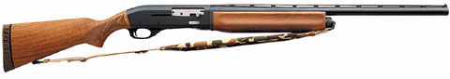

**Overview:**

|  |  |
| --- | --- |
| **Manufacturer:** | **Remington** |
| **Description:** | Gas-operated 10-gauge autoloading shotgun. |
|  |  |
| **Introduction Year:** | 1989 |
|  |  |
| **Year Discontinued:** | 2012? |
|  |  |
| **Total Production:** | N/A |
|  |  |
| **Designer/Inventor:** | Remington Arms Company, Inc. |
|  |  |
| **Action Type:** | Autoloading |
|  |  |
| **Caliber/Gauge:** | 10 gauge (1990) |
|  |  |
|  |  |
| **Serial Number Blocks:** | 1989 only: LE89**** 1990 - Present: RM****** |
| **Variations:** | SP-10 Magnum (1989 - Present)  SP-10 Magnum Turkey Combo (1991 - 1994)  SP-10 Magnum Camo (1993 - Present)             Mossy Oak® Bottomland® (1993-1996)            Mossy Oak® Break-Up® (1997 - 2004)            Mossy Oak® Obsession® (2005 - Present)  SP-10 Magnum Camo NWTF 25th Anniversary (1998)  SP-10 Magnum Turkey Camo (1999 - 2001)  SP-10 Magnum Synthetic (2000-2004) |

**versamax**

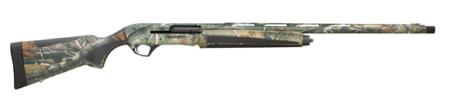

**Overview:**

The new standard for reliability in autoloading shotguns. VERSA MAX® shatters convention and all previous benchmarks for reliability with an action unlike any that have come before it. Proven in the field and in extreme tests of endurance with thousands of test rounds, it cycles 12-gauge loads with ultimate consistency, softer recoil and less maintenance than you've ever experienced.

**Key Features:**

• Most versatile, reliable shotgun on the market.

• Reliably cycles 12-gauge rounds from 2 3/4" to 3 1/2" magnum.

•Versaport™ gas system regulates cycling pressure based on shell length.

• Reduces recoil to that of a 20-gauge.

• Self-cleaning - Continuously cycled thousands of rounds in torture test.

• Synthetic stock and fore-end with grey overmolded grips.

• Drilled and tapped receiver.

• Enlarged trigger guard opening and larger safety for easier use with gloves.

•TriNyte® Barrel and Nickel Teflon plated internal components offer extreme corrosion resistance.

• Includes 5 Flush Mount Pro Bore™ Chokes (Improved Cylinder, Light Mod, Mod, Improved Mod, and Full)

|  |  |
| --- | --- |
| **Manufacturer:** | **Remington** |
| **Description:** | Gas operated 5-shot autoloading shotgun |
|  |  |
| **Introduction Year:** | 2010 |
|  |  |
| **Year Discontinued:** | Currently in Production |
|  |  |
|  |  |
| **Designer/Inventor:** | Remington Research & Development |
|  |  |
| **Action Type:** | Autoloading |
|  |  |
| **Caliber/Gauge:** | 12 |
|  |  |
| **Grades:** |  |

**v3**

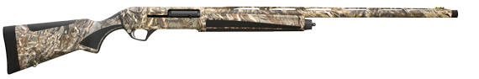

**Overview:**

The new standard for reliability in autoloading shotguns. VERSA MAX® shatters convention and all previous benchmarks for reliability with an action unlike any that have come before it. Proven in the field and in extreme tests of endurance with thousands of test rounds, it cycles 12-gauge loads with ultimate consistency, softer recoil and less maintenance than you've ever experienced.

**Key Features:**

• Most versatile, reliable shotgun on the market.

• Reliably cycles 12-gauge rounds from 2 3/4" to 3" magnum.

•Versaport™ gas system regulates cycling pressure based on shell length.

• Reduces recoil to that of a 20-gauge.

• Self-cleaning - Continuously cycled thousands of rounds in torture test.

• Synthetic stock and fore-end with grey overmolded grips.

• Drilled and tapped receiver.

• Enlarged trigger guard opening and larger safety for easier use with gloves.

•TriNyte® Barrel and Nickel Teflon plated internal components offer extreme corrosion resistance.

• Includes 5 Flush Mount Pro Bore™ Chokes (Improved Cylinder, Light Mod, Mod, Improved Mod, and Full)

|  |  |
| --- | --- |
| **Manufacturer:** | **Remington** |
| **Description:** | Gas operated 5-shot autoloading shotgun |
|  |  |
| **Introduction Year:** | 2015 |
|  |  |
| **Year Discontinued:** | Currently in Production |
|  |  |
| **Total Production:** | N/A |
|  |  |
| **Designer/Inventor:** | Remington Research & Development |
|  |  |
| **Action Type:** | Autoloading |
|  |  |
| **Caliber/Gauge:** | 12 |
|  |  |
|  |  |
|  |  |
| **Variations:** | V3 – Field Sport Walnut  V3 – Field Sport Synthetic Camo  V3 – Field Sport Synthetic |

**Pump shotguns**

**model 10**

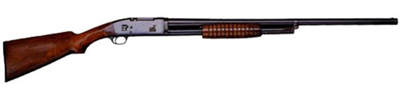

**Overview:**

|  |  |
| --- | --- |
| **Manufacturer:** | **Remington** |
| **Description:** | Remington's first pump-action six-shot repeating shotgun. |
|  |  |
| **Introduction Year:** | 1908 |
|  |  |
| **Year Discontinued:** | 1929 |
|  |  |
| **Total Production:** | Approximately 275,600 |
|  |  |
| **Designer/Inventor:** | John D. Pederson with improvements by C.C. Loomis and R. Barger |
|  |  |
| **Action Type:** | Pump action repeater |
|  |  |
| **Caliber/Gauge:** | 12 |
|  |  |
|  |  |
| **Serial Number Blocks:** | 001 – 275,600 Serial numbers were preceded by the letter "U" |
| **Grades Offered:** | No. 1 or 10 A - Standard or Field Grade No. 2 or 10 B - Special Grade No. 3 or 10 C - Trap Grade No. 3 Trap Special Grade No. 4 or 10 D - Tournament Grade No. 5 or 10 E - Expert Grade No. 6 or 10 F - Premier Grade No. 0 Riot Grade |
| **Variations:** | Model 10 Trench Shotgun (World War 1) Model 10 T – Target Grade which included grades D, E, and F as described above |

**model 17**

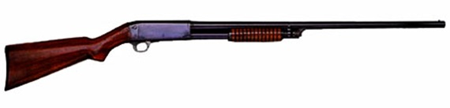

|  |  |
| --- | --- |
| **Manufacturer:** | **Remington** |
| **Description:** | Pump action, hammerless, under-loading, tubular-magazine, bottom-ejecting, takedown shotgun |
|  |  |
| **Introduction Year:** | 1921 |
|  |  |
| **Year Discontinued:** | 1933 |
|  |  |
| **Total Production:** | Approximately 73,000 |
|  |  |
| **Designer/Inventor:** | John Browning, John Pedersen |
|  |  |
| **Action Type:** | Pump action repeater |
|  |  |
| **Caliber/Gauge:** | 20 gauge only. |
|  |  |
|  |  |
| **Serial Number Blocks:** | 0,000 – 73,000 |
| **Grades Offered:** | 17A – Standard Grade 17B – Special Grade 17D – Tournament Grade 17E – Expert Grade 17F – Premier Grade 17R – Riot Grade 17P – Police Grade |
| **Variations:** | None |

**model 29**



|  |  |
| --- | --- |
| **Manufacturer:** | **Remington** |
| **Description:** | Pump action, hammerless, under-loading, tubular-magazine, bottom-ejecting, takedown shotgun |
|  |  |
| **Introduction Year:** | 1930 |
|  |  |
| **Year Discontinued:** | 1933 |
|  |  |
| **Total Production:** | Approximately 38,000 |
|  |  |
| **Designer/Inventor:** | C.C. Loomis |
|  |  |
| **Action Type:** | Pump action repeater |
|  |  |
| **Caliber/Gauge:** | 12 gauge for use with 2 ¾-inch shells. |
|  |  |
|  |  |
| **Serial Number Blocks:** | 0,000 – 38,000 |
| **Grades Offered:** | 29A – Standard Grade 29B – Special Grade 29C – Trap Grade 29D – Tournament Grade 29E – Expert Grade 29F – Premier Grade 29R – Riot Grade |
| **Variations:** | 29T- Special Trap Gun including the Target, Tournament, Expert and Premier grades |

**model 31**



|  |  |
| --- | --- |
| **Manufacturer:** | **Remington** |
| **Description:** | Remington's first side ejecting repeating shotgun. |
|  |  |
| **Introduction Year:** | 1931 |
|  |  |
| **Year Discontinued:** | 1949 |
|  |  |
| **Total Production:** | Approximately 196,000 |
|  |  |
| **Designer/Inventor:** | C.C. Loomis |
|  |  |
| **Action Type:** | Pump action repeater |
|  |  |
| **Caliber/Gauge:** | 12, 16, 20 gauge |
| **Serial Number Blocks:** | 12 ga. 0,000 – 121,000 16 & 20 ga. 500,000 – 575,000 |
| **Grades Offered:** | 31A 31AC 31AP – Standard Grade 31B – Special Grade 31D – Tournament Grade 31E – Expert Grade 31F – Premier Grade 31H – Hunter's Special 31P – Police Grade 31R – Riot Grade 31 Skeet 31D Skeet Tournament 31E Skeet Expert 31F Skeet Premier 31 Trap Special Grade 31S-D Trap Tournament 31S-E Trap Expert 31S-F Trap Premier 31TC Trap (or Tournament) Grade 31T-D Target Tournament 31T-E Target Expert 31T-F Target Premier |
| **Variations:** | Model 31 New Improved in a Skeet Gun, TC Target Grade, Police Special, and Riot Gun  Model 31 New Improved Lightweight with Aluminum Receivers in A,B, D, E, F, Skeet, and Riot Grades (the letter “L” preceded the grade.)  Model 31 Long-Range in A Grade, New Improved A Grade, Trap Grade, Hunter’s Special Grade, and Trap Grade (the letter ”X” preceded the grade. |

**WINGMASTER**

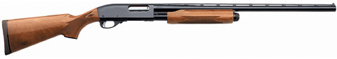

**Overview:**

|  |  |
| --- | --- |
| **Manufacturer:** | **Remington** |
| **Description:** | The greatest selling pump action shotgun in the history of firearms. |
|  |  |
| **Introduction Year:** | 1951 |
|  |  |
| **Year Discontinued:** | Currently in production |
|  |  |
| **Total Production:** | +10 million |
|  |  |
| **Designer/Inventor:** | L.RayCrittendon, Phillip Haskell, Ellis Hailston, and G.E. Pinckney |
|  |  |
| **Action Type:** | Pump action |
|  |  |
| **Caliber/Gauge:** | 12, 16, 20, 28, .410 bore |
|  |  |
|  |  |
| **Serial Number Blocks:** | Information not publicly available. |
| **Grades Offered:** | 12 gauge:   * 870 Wingmaster Cantilever * 870 Wingmaster Super Magnum * 870 Wingmaster Dale Earnhardt Limited Edition   16 gauge:   * 870 Wingmaster   20 gauge:   * 870 Wingmaster Limited * 870 Wingmaster Youth * 870 Wingmaster 3” * 870 Wingmaster Jr. * 870 Wingmaster Dale Earnhardt Tribute   28 gauge:   * 870 Wingmaster Plain barrel * 870 Wingmaster Vent Rib barrel * 870 Wingmaster matched pair w/ .410 * 870 Wingmaster SA Skeet   .410 bore:   * 870 Wingmaster Plain barrel * 870 Wingmaster Vent Rib barrel * 870 Wingmaster matched pair w/ .410 * 870 Wingmaster SA Skeet |

**870**



**Overview:**

|  |  |
| --- | --- |
| **Manufacturer:** | Remington |
| **Description:** | The greatest selling pump action shotgun in the history of firearms. |
|  |  |
| **Introduction Year:** | 1951 |
|  |  |
| **Year Discontinued:** | Currently in production |
|  |  |
| **Total Production:** | +10 million |
|  |  |
| **Designer/Inventor:** | L.Ray Crittendon, Phillip Haskell, Ellis Hailston, and G.E. Pinckney |
|  |  |
| **Action Type:** | Pump action |
|  |  |
| **Caliber/Gauge:** | 12, 16, 20, 28, .410 bore |
|  |  |
|  |  |
| **Serial Number Blocks:** | Information not publicly available. |
| **Grades Offered:** | 12 gauge:   * 870 AP * 870 BC Special Grade * 870 ADL Deluxe Grade * 870 BDL Deluxe Grade * 870D Tournament Grade * 870F Premier Grade * 870TC Trap Grade * 870TD Trap Tournament Grade * 870TF Trap Premier Grade * 870S Trap Special Grade * 870SA Skeet Grade * 870SB Skeet Grade * 870SD Skeet Tournament Grade * 870SF Skeet Premier Grade * 870R Riot Grade * 870 Magnum-AP * 870 Magnum ADL Deluxe Grade * 870 RSS Rifled Slug Special * 870 SX Skeet Grade * 870 TX Trap Grade * 870 ADX Field Grade * 870 ADX * 870 AP Brushmaster * 870 150th Anniversary Edition * 870 Field Grade Left Hand * 870 Magnum Left Hand * 870 Trap Grade Left Hand * 870 All American Special Trap Grade * 870 Ducks Unlimited Limited Edition * 870 Bicentennial Commemorative * 870 SA Skeet Grade * 870 TB Trap Grade * 870 TBMS Trap * 870 Competition Trap * 870 Ducks Unlimited Commemorative Mississippi Magnum * 870 Deer Gun * 870 Special Field * 870 SP Special Purpose Magnum * 870 SP Special Purpose Deer Gun * 870 Express * 870 SP w/ Rem Choke * 870 Express Combo * 870 TC Trap Grade * 870 Express Turkey * 870 Express Cantilever Scope Mount Deer Gun * 870 Express Rifle Sighted Deer Gun * 870 SP Cantilever Scope Mount Deer Gun * 870 SPS Special Purpose Synthetic * 870 SPS-T Special Purpose Synthetic Turkey * 870 Marine Magnum * 870 SPS BG-Camo * 870 SPS-Deer * 870 Express HD * 870 TC Trap * 870 Express Super Magnum * 870 Synthetic Super Magnum * 870 Synthetic Camo w/ Advantage Camo * 870 Super Magnum Combo * 870 Express Turkey Camo w/ Advantage Camo * 870 SPS Super Magnum Camo * 870 SPS-T Super Magnum Camo * 870 SPS Super Slug Deer * 870 Express Super Magnum Turkey * 870 Express Synthetic Deer * 870 50th Anniversary Classic Trap * 870 SPS-T RS/TG * 870 SPS-T Super Magnum Camo CL/RD * 870 SPS-T Super Magnum Camo CL/RC * 870 SPS-T Camo RS/TG * 870 SPS Super Magnum Camo * 870 Classic Trap * 870 SPS-Youth RS/TG Turkey Camo * 870 Express Super Magnum Turkey Camo * 870 Express Turkey Camo * 870 SP-T Super Magnum Thumbhole stock * 870 Express Super Magnum “Fall Flight” * 870 NRA Edition * 870 Special Purpose Thumbhole Stock   16 gauge:   * 870 AP * 870 BC Special Grade * 870 ADL Deluxe Grade * 870 BDL Deluxe Grade * 870D Tournament Grade * 870F Premier Grade * 870TC Trap Grade * 870TD Trap Tournament Grade * 870TF Trap Premier Grade * 870S Trap Special Grade * 870SA Skeet Grade * 870SB Skeet Grade * 870SD Skeet Tournament Grade * 870SF Skeet Premier Grade * 870R Riot Grade * 870 ADX * 870 AP Brushmaster * 870 Express * 870 Express Synthetic * 870 Express Synthetic Youth   20 gauge:   * 870 AP * 870 BC Special Grade * 870 ADL Deluxe Grade * 870 BDL Deluxe Grade * 870D Tournament Grade * 870F Premier Grade * 870TC Trap Grade * 870TD Trap Tournament Grade * 870TF Trap Premier Grade * 870S Trap Special Grade * 870SA Skeet Grade * 870SB Skeet Grade * 870SD Skeet Tournament Grade * 870SF Skeet Premier Grade * 870R Riot Grade * 870 ADX * 870 AP Brushmaster * 870 Field Grade Left Hand * 870 Magnum Left Hand * 870 Trap Grade Left Hand * 870 Brushmaster * 870 Special Field * 870 Express * 870 Express Combo * 870 Express Youth Deer Gun * 870 Express Youth Turkey Camo * 870 Express Jr. NWTF   28 gauge:   * 870 Express   .410 bore:   * 870 Express |
|  |  |
|  |  |

**Sportsman 12**



**Overview:**

|  |  |
| --- | --- |
| **Manufacturer:** | **Remington** |
| **Description:** | Remington's first pump-action six-shot repeating shotgun. |
|  |  |
| **Introduction Year:** | 1908 |
|  |  |
| **Year Discontinued:** | 1929 |
|  |  |
| **Total Production:** | Approximately 275,600 |
|  |  |
| **Designer/Inventor:** | John D. Pederson with improvements by C.C. Loomis and R. Barger |
|  |  |
| **Action Type:** | Pump action repeater |
|  |  |
| **Caliber/Gauge:** | 12 |
|  |  |
|  |  |
| **Serial Number Blocks:** | unknown |
| **Grades Offered:** | one |
| **Variations:** | magnum |
|  |  |
|  |  |

The Sportsman series started in 1984 with 4 guns, a 12 ga pump, a 30-06 pump, a 30-06 semi-auto and a 30-06/270 bolt action. The 1985 catalog lists those four plus the auto loading 12 ga which you have. These guns all had the hardwood stocks but still had bright blued metal. The were made to sell at the large chain stores at a reduced price compared to the regular models. They were marked "Sportsman 12 Pump, Sportsman 12 Auto, Sportsman 74, Sportsman 76 and Sportsman 78". The shotguns were last listed in the 1986 catalog. The rifles were last listed in the 1987 catalog. However a sixth gun was added in 1986, the 581S 22 caliber which lasted thru 1999. The caliber list was expanded for the Sportsman 78 bolt action in 1985 to include 308 and 243 calibers, in 1986 the 223 was added. The shotguns were made in two barrel lengths, 30 inch full and 28 inch with rem chokes.

**887 Tactical**

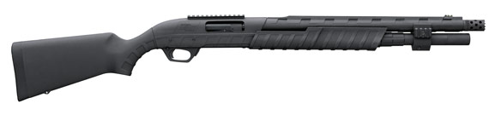

**Overview:**

|  |  |
| --- | --- |
| **Manufacturer:** | **Remington** |
| **Description:** | The most durable shotgun on the planet. Born of the gunmaking expertise that brought you the best-selling, most trusted shotgun of all time, the Model 870, the Model 887 Nitro Mag is an armor-clad warrior here to carry the torch of our great pump-gun legacy through the most extreme conditions on earth. Our exclusive [ArmorLokt™](http://www.remington.com/pages/armorlokt.aspx) process seals the receiver and barrel in a vault of weather-impervious synthetic armor that's both completely rustproof and tough as nails. Similar to the Model 870, it's receiver is crafted of solid steel and the barrel is hammer forged to last a lifetime. Twin steel action bars ensure smooth, positive chambering and ejection. And the sleek receiver design, awesome balance and natural pointing characteristics spell trouble for any bird within reach of its 12-gauge 3 1/2" Super Magnum capability. The extremely rugged synthetic stock and fore-end are ergonomically contoured to offer a positive grip and comfortable handling. Swivel studs are built-in.  For 2010, our new Model 887 Nitro Mag Tactical combines supreme toughness and dependability with a handy 18 1/2" barrel, a 2-shot magazine extension and a barrel clamp with integral Picatinny rails for mounting your flashlight or other accessories. It also includes a ported, extended tactical Rem™ Choke and receiver mounted on Picatinny rail. |
|  |  |
| **Introduction Year:** | 2010 |
|  |  |
| **Year Discontinued:** | Currently in production |
|  |  |
| **Total Production:** |  |
|  |  |
| **Designer/Inventor:** | L.RayCrittendon, Phillip Haskell, Ellis Hailston, and G.E. Pinckney |
|  |  |
| **Action Type:** | Pump action |
|  |  |
| **Caliber/Gauge:** | 12guage. |
|  |  |
|  |  |
| **Serial Number Blocks:** | Not made publicly available. |
| **Grades Offered:** | One |
| **Variations:** | Model 887 Nitro Mag  Model 887 Nitro Mag Waterfowl  Model 887 Nitro Mag Camo Combo  Model 887 Nitro Mag Tactical |

**Single Shot shotguns**

**remington percussion 1866-1877**

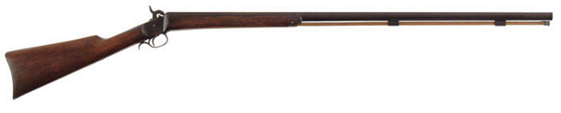

**Overview:**

|  |  |
| --- | --- |
| **Manufacturer:** | **Remington** |
| **Description:** |  |
|  |  |
| **Introduction Year:** | 1866 |
|  |  |
| **Year Discontinued:** | 1877 |
|  |  |
| **Total Production:** |  |
|  |  |
| **Designer/Inventor:** |  |
|  |  |
| **Action Type:** | Muzzle loading, Percussion cap |
|  |  |
| **Caliber/Gauge:** | 20 guage. |
|  |  |
|  |  |
| **Serial Number Blocks:** | Not made publicly available. |
| **Grades Offered:** | One |
| **Variations:** | none |

**Model 1**

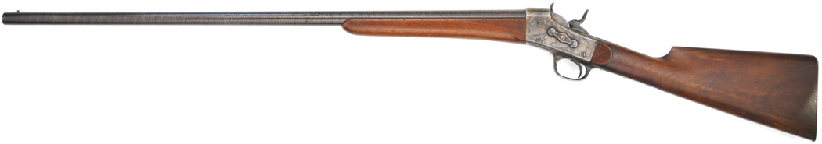

**Overview:**

|  |  |
| --- | --- |
| **Manufacturer:** | **Remington** |
| **Description:** | Civilian Shotgun |
|  |  |
| **Introduction Year:** | 1877 |
|  |  |
| **Year Discontinued:** | 1890 |
|  |  |
| **Total Production:** |  |
|  |  |
| **Designer/Inventor:** |  |
|  |  |
| **Action Type:** | Rolling block |
|  |  |
| **Caliber/Gauge:** | 16B guage. |
|  |  |
|  |  |
| **Grades Offered:** | Laminated Barrels  Engraved  Extra Engraved  Plain Barrel |
| **Variations:** | None |

**Model 2**



**Overview:**

|  |  |
| --- | --- |
| **Manufacturer:** | **Remington** |
| **Description:** | Military Foraging shotgun |
|  |  |
| **Introduction Year:** | 1877 |
|  |  |
| **Year Discontinued:** | 1890 |
|  |  |
| **Total Production:** |  |
|  |  |
| **Designer/Inventor:** |  |
|  |  |
| **Action Type:** | Rolling block |
|  |  |
| **Caliber/Gauge:** | 16B guage. |
|  |  |
|  |  |
| **Grades Offered:** | Military Grade |
| **Variations:** | None |

**model 1893 #3**

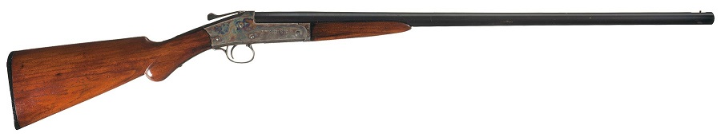

**Overview:**

|  |  |
| --- | --- |
| **Manufacturer:** | **Remington** |
| **Description:** | Break open, top lever activated with cocking lever on left side of receiver. |
|  |  |
| **Introduction Year:** | 1893 |
|  |  |
| **Year Discontinued:** | 1903 |
|  |  |
| **Total Production:** | 86,000 +/- |
|  |  |
| **Designer/Inventor:** |  |
|  |  |
| **Action Type:** | Break action |
|  |  |
| **Caliber/Gauge:** | 10,12,16,20,24,28 gauge |
|  |  |
| **Serial Number:** | 1,001 – 90,000 |
| **Grades Offered:** | None |
| **Variations:** | None |

**model 1902 #9**



**Overview:**

|  |  |
| --- | --- |
| **Manufacturer:** | **Remington** |
| **Description:** | Improved version of the Model 3 |
|  |  |
| **Introduction Year:** | 1902 |
|  |  |
| **Year Discontinued:** | 1910 |
|  |  |
| **Total Production:** | 66,000 +/- |
|  |  |
| **Designer/Inventor:** | Fay patents |
|  |  |
| **Action Type:** | Break action |
|  |  |
| **Caliber/Gauge:** | 10,12,16,20,24,28 gauge. |
|  |  |
| **Serial Number:** | Approximately 90,000 – 451,000 – There were several blocks used during production of this model |
| **Grades Offered:** | None |
| **Variations:** | None |

**MODEL 90-T**

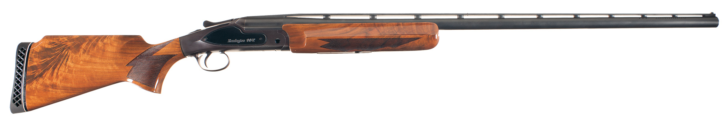

**Overview:**

|  |  |
| --- | --- |
| **Description:** | Single-barrel Trap gun |
|  |  |
| **Introduction Year:** | 1991 |
|  |  |
| **Year Discontinued:** | 1997 |
|  |  |
| **Total Production:** | Information not available |
|  |  |
| **Designer/Inventor:** | U.S. Competition Arms |
|  |  |
| **Action Type:** | Break open mono-block system |
|  |  |
| **Caliber/Gauge:** | 12 gauge |
|  |  |
| **Serial Number Blocks:** | Serial numbers were preceded by "ST" Serial number blocks not available |
|  |  |
| **# of Grades Offered:** | Standard grade Custom made and adjustable comb stocks were available on special order |
|  |  |
| **Variations:** | 90-T HPAR – High Post Adjustable Rib |

**Model 310RF**

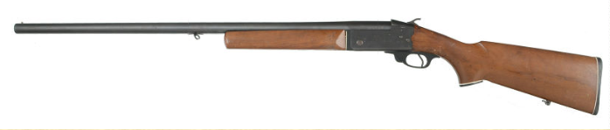

**Overview:**

|  |  |
| --- | --- |
| **Description:** | Single-barrel Skeet gun |
|  |  |
| **Introduction Year:** | 1960 |
|  |  |
|  |  |
|  |  |
|  |  |
|  |  |
|  |  |
|  |  |
|  |  |
|  |  |
|  |  |
|  |  |
|  |  |
|  |  |
|  |  |
|  |  |
|  |  |

**SPR 100**

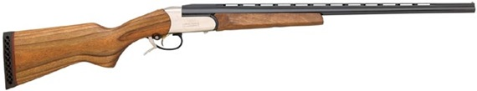

SN: 07030796R (Made in 2007) $109.00

**Overview:**

|  |  |
| --- | --- |
| **Description:** | Single Shot Shotgun |
|  |  |
| **Introduction Year:** | 2006 (Previously Spartan Gunworks by Remington, Introduction 2005) |
|  |  |
| **Year Discontinued:** | 2008 |
|  |  |
| **Total Production:** | N/A |
|  |  |
| **Designer/Inventor:** | International Sporting Product manufactured in Baikal, Russia |
|  |  |
| **Action Type:** | Single Shot |
|  |  |
| **Caliber/Gauge:** | 12 gauge 20 gauge 410 gauge |
|  |  |
| **Serial Number Blocks:** | N/A |
|  |  |
| **Variations:** | Field:   * SPR100 Single-Shot Shotgun * SPR100 Single-Shot 26” Barrel * SPR100 Max Nickel Receiver   Sporting:   * SPR100 Sporting Nickel Receiver   Youth:   * SPR100 Single-Shot Youth * SPR100 Max Nickel Receiver Youth |

**Model 812**



|  |  |
| --- | --- |
| **Introduction Year:** | 1970 |
|  |  |
| **Year Discontinued:** | 1970 |
|  |  |
| **Total Production:** |  |
|  |  |
| **Designer/Inventor:** |  |
|  |  |
| **Action Type:** |  |
|  |  |
| **Caliber/Gauge:** | 12 gauge. |
|  |  |

**Model 510 sb**

**Model 511 sb**

**Model 512 sb**

**Model 514 sb**

**Model 121 sb PUMP**

**Model 572 sb PUMP**